An Improved Super-Twisting Sliding Mode for Flexible

Upper-Limb Exoskeleton

Saihua Zhang, Xinghua Zhang and Zhenxing Sun

Abstract

Aiming at the decrease of tracking accuracy caused by nonlinear friction and strong coupling of flexible upper-limb exoskeleton, an improved super-twisted second-order sliding mode controller (ISTSMC) is proposed. Compared with the conventional super twisted sliding mode controller (STSMC), this method can replace the switching function under the integral term with a nonsmooth term, resulting in faster response and less vibration when performing trajectory tracking, and reduced steady-state error. The effectiveness and feasibility of the proposed control algorithm are verified through experiments.

Keywords

Flexible upper limb exoskeleton, second order sliding mode, improved super-twisting control law

1.Introduction

Studies show that stroke has become the second leading cause of death in the world and the leading cause of disability among the elderly[1]. Among them, nearly 80% of stroke survivors will experience different degrees of limb function and movement disorders, seriously affecting people's activities of daily living and quality of life [2]. Currently, most rehabilitation training is dependent on caregivers, which is time-consuming and labor-intensive [3]. With the development of exoskeleton robots in recent decades, it has made huge strides in medical fields [4]. Taking the field of medical rehabilitation as an example, exoskeleton robots have greatly reduced labor costs [5]. After analyzing the recovery time of patients, the rehabilitation training is divided into two ways: one is passive control, because the patient lacks exercise ability, the robot needs to play a leading role in the movement; the other is active control, the patient has a certain exercise ability, the robot plays the role of following movement [6-7]. The flexible upper limb exoskeleton is a rigid-flexible coupled nonlinear system, which is susceptible to external perturbations and structural parameters during motion, so designing a suitable controller for trajectory tracking is the key problem of research [8-9].

In order to improve the accuracy task of the exoskeleton, the flexibility of the joints needs to be considered when designing the controller. How to design high-performance controllers has attracted widespread attention from scholars. In [10], the MARSE-4 exoskeleton robot was teleoperated by an upper limb exoskeleton master hand using a linear PID control method,, experiments show that MARSE-4 can effectively track the desired trajectory and passively treat the movements of the patient's wrist, elbow and forearm, and achieve satisfactory training results. Different from the PID control method, the sliding mode control can change purposefully according to the current state of the system in the dynamic process, forcing the system to move according to the state trajectory of the predetermined sliding mode [11-15]. In the literature [16], a modular control system to drive the exoskeleton to perform rehabilitation tasks using a fast terminal sliding mode method. The controller has been applied to drive an upper limb exoskeleton with three degrees of freedom in real time. As a further extension of work [17], a five-degree-of-freedom upper limb rehabilitation exoskeleton based on a finite-time disturbance observer and non-singular fast terminal sliding mode control to solve the problems of modeling uncertainty and unknown disturbances in robotic systems. The unknown perturbation is estimated and compensated simultaneously by a finite-time perturbation observer, which can estimate the perturbation in less than 0.05 s with zero error. The initial state of the system will affect the finite-time convergence, resulting in limitations in practical applications.

Based on the above research, this paper proposes an improved super-twisting second-order sliding mode controller based on a flexible upper limb exoskeleton. Compared with the traditional super-twisting algorithm, the switching function is replaced by a nonsmooth term. The errors and vibration in the control of the system are reduced, and the selection of suitable parameters improves the anti-interference of the system. The effectiveness of the algorithm was verified by conducting experiments on a flexible upper limb exoskeleton platform.

The rest of the paper is set as follows. Section 2 expresses the dynamic modeling and controller design. Section 3 is the stability analysis of the controller. Section 4 shows the measured data of the proposed ISTSMC on the experimental platform for comparison and analysis with the experiments of PID and STSMC. Conclusion is presented in Section 5.

2.Modeling and algorithm design

2.1 modeling design

The flexible upper limb exoskeleton is mainly composed of DC motors, motion control boards and corresponding measurement components and other components. Considering the joint flexibility, load friction and disturbance, the flexible joint system is constructed, and the following dynamics equation can be obtained:

 (1),

where  is the angle of rotation at the joint,  is the motor side rotation angle. denotes the motor-side rotor rotational inertia, damping and torsion spring elasticity coefficients, respectively.  is the rotational inertia matrix of the exoskeleton.  is the Gauche and centripetal force matrix.  is the gravity matrix of the exoskeleton robot.  is the control torque vector. To facilitate the design of the controller, let and transform the kinetic equation into the following equation of state:

 (2)

 (3)

where 



is the external disturbance on the motor side and joint side, is the unmatched disturbance and the matched disturbance in the system, including the unmolded dynamics of the system and external disturbances.

2.2Controller design

First, defining the sliding surface of the system as follows:

 (4),

where .

Derivation of the sliding surface:

 (5)

According to the equations (2), (3)and the improved super-twisting-like fractional control law proposed in the literature [18], the specific control law of the system can be obtained as:

 (6)

where is the controller gain greater than 0 and is an adjustable parameter and the range is -0.5-0.

3. Stability Analysis

Assumption 1: All perturbations in the flexible lower limb exoskeleton system and their derivative values of all orders are bounded, i.e., they satisfy , where is positive.

Lemma 1: [19] Suppose,then for,

.

Lemma 2:[20] Assuming that ,then for,



Lemma 3: [21] Let and,then for,



whereis a positive function.

Lemma 4:[21] Suppose that the positive-definite function and function have the same homogeneous degree pertaining to the same dilation weight. Then, there exists a positive constant, such that.In addition, if is positive-definite, one has , where  is a positive constant.

Definition1:[22] Given real numbers  and fixed coordinates. If there exists a real number , such that for and, one has, then the function is called homogeneous of degree , where  is the weights of the coordinates.

Substituting (6) into (5) yields：

 (7)

where , the above equation can be rewritten as:

 (8)

Let ,one has:

 (9)

For the convenience of calculation:

 (10)

According to Lemmas 1 and , we can obtain

 (11)

According to Lemma 4, we can obtain

 (12)

where 

Design the Lyapunov function as follows

 (13)

where and .

Derivative for ,one has

 (14)

 (15)

According to Lemma 3 and (11)

 (16)

where .By using (15) and (16)，one has

 (17)

The same reason can be proved

 (18)

where .

By combining (14)，(17)and(18)，we have

 (19)

In selecting , make,one has

 (20)

where 

By employing Assumption 1, it is not difficult to obtain

 (21)

Definition ,where  is a positive constant and is a sufficiently small constant.

Since ,one has

 (22)

According to Definition 1, we can get  and  are homogeneous of degree  pertaining to the dilation weight .

From Lemma 4,one has

 (23)

Substituting (23) in (21) yields

 (24)

Through (22),it yields



In order to ensure that the system can exist at any initial moment for a time such that .



According to Definition 1, we can get  and  are homogeneous of degree  pertaining to the dilation weight .

From Lemma 4, one has

 (25)

From (25), it follows that there exists a time  such that .When , there exists

 (26)

 (27)

Since ,one has

 (28)

 (29)

From the above two equations, it follows that  and  converge to the infinitesimal range in finite time again.

4. Experimental analysis

A two-degree-of-freedom upper limb flexible exoskeleton experimental device is used, and the constructed platform is shown in Figure 1. The main body of the platform consists of two MAXON DC motors, two reducers and two rigid connecting rods. The first joint is connected to motor 1 through a spring, the end of the joint is motor 2, and the second joint is connected through a spring. Each motor has a quadrature encoder on the bottom and joint side. The springs at both joints are replaceable to adjust the flexibility of the joints.

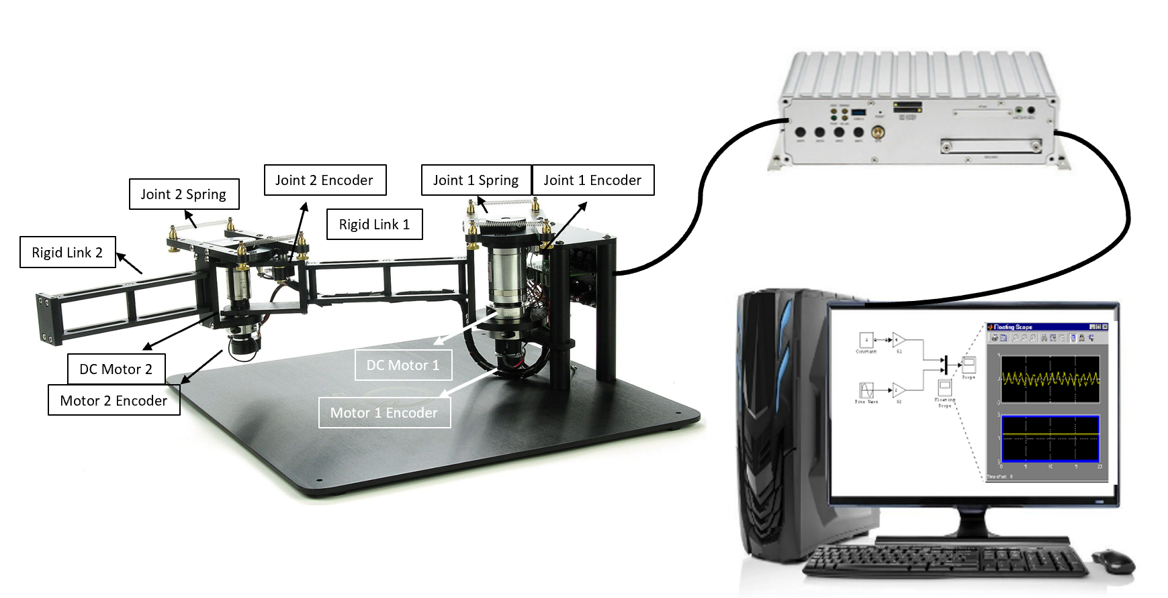

Fig 1 The experiment platform

In order to verify the effectiveness of ISTSMC, the experimental analysis was conducted on the flexible upper limb exoskeleton experimental platform. Two types of common control algorithms, PID control and STSMC algorithm, are used to conduct valid comparisons in order to provide a suitable control performance comparison result.

To simulate the flexion and extension of the arm, the experiment started with an angle of 160 degrees between the first link and second link, and the set trajectory was two sine functions that could simulate the flexion and extension of the upper limb The initial angle of the two joints before the start of the experiment is 0 degrees, and the set trajectory of the joint 1 is and the trajectory of the joint 2 is .

2the PID has an overshoot of 11%, and the adjustment time is 2.3s. Neither STSMC nor ISTSMC overshoot, but the regulation time of ISTSMC is 0.5s faster than STSMC. At 1.1s, the STSMC has a jitter phenomenon due to the effect of the differential term.

From Figure 3(a) joint 1 trajectory tracking and Figure 4(a) joint 2 trajectory tracking, it can be seen that the control response of STSMC and ISTSMC is faster than PID control, and can track the upper trajectory at 0.1s; The state can see that ISTSMC has smaller error than PID and STMSMC. The trajectory tracking has a "flat top phenomenon", which is caused by the elastic structure of the spring, which makes the system have a certain hysteresis effect during the commutation process.

From Fig. 3(b) joint 1 error and Fig. 4(b) joint 2 error, it can be seen that under the ISTSMC algorithm, the steady-state error of joint 1 is about 70% less than that of PID, and the commutation error is 10% less than that of STSMC. 2 has 50% less error than PID and STSMC. At 4s and 10s, the joint trajectories are reversed. Due to the deformation of the torsion spring, the two joints have the largest error, but they are within the acceptable range. The overall tracking error of ISTSMC is smaller than that of PID control and STSMC.

It can be seen from Figure 3(c) and Figure 4(c) that the control torque of ISTSMC is similar to the other two methods, but the control effect is significantly improved, and the vibration is also reduced.

To sum up, the flexible upper limb exoskeleton ISTSMC runs more stably, with higher control accuracy and smaller steady-state error.

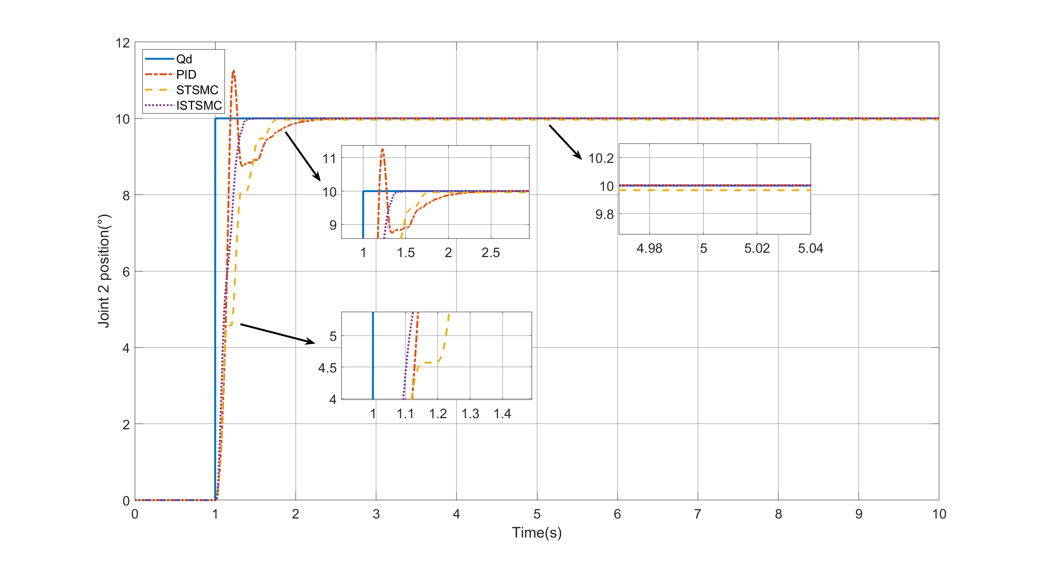

(a)

 

(b) (c)

Fig.2 Joint 2 under step (a) Trajectory tracking diagram (b) Trajectory tracking error diagram(c) control input diagram

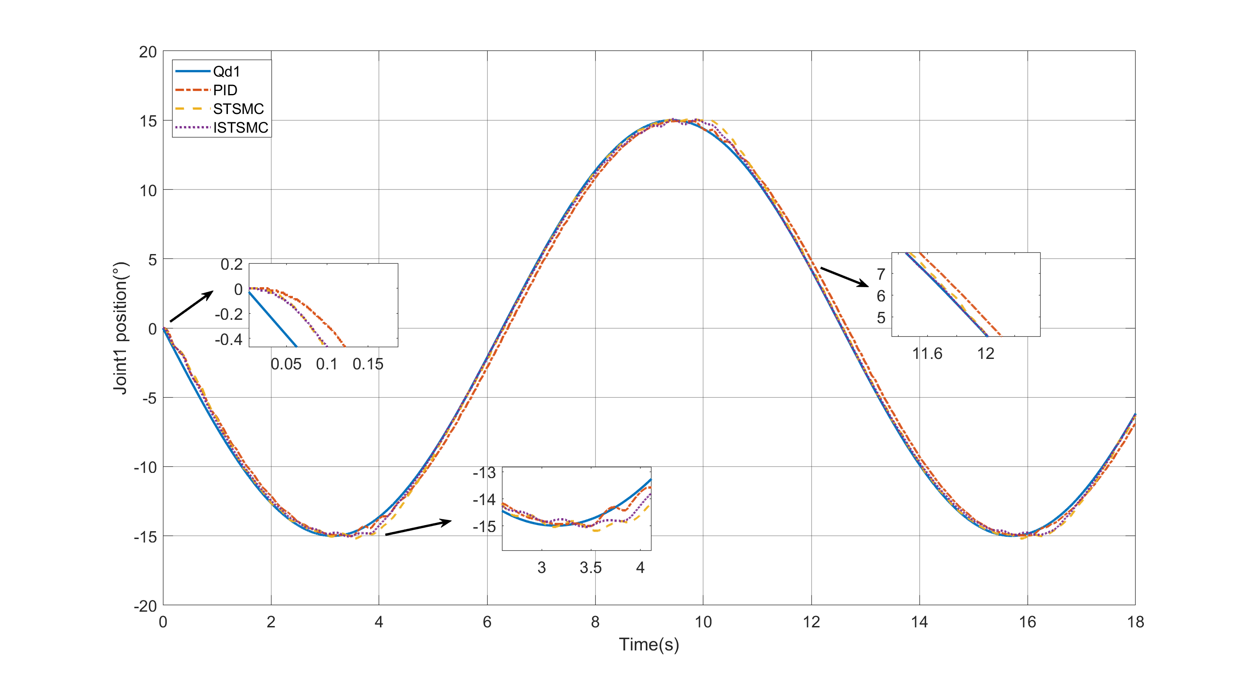

(a)

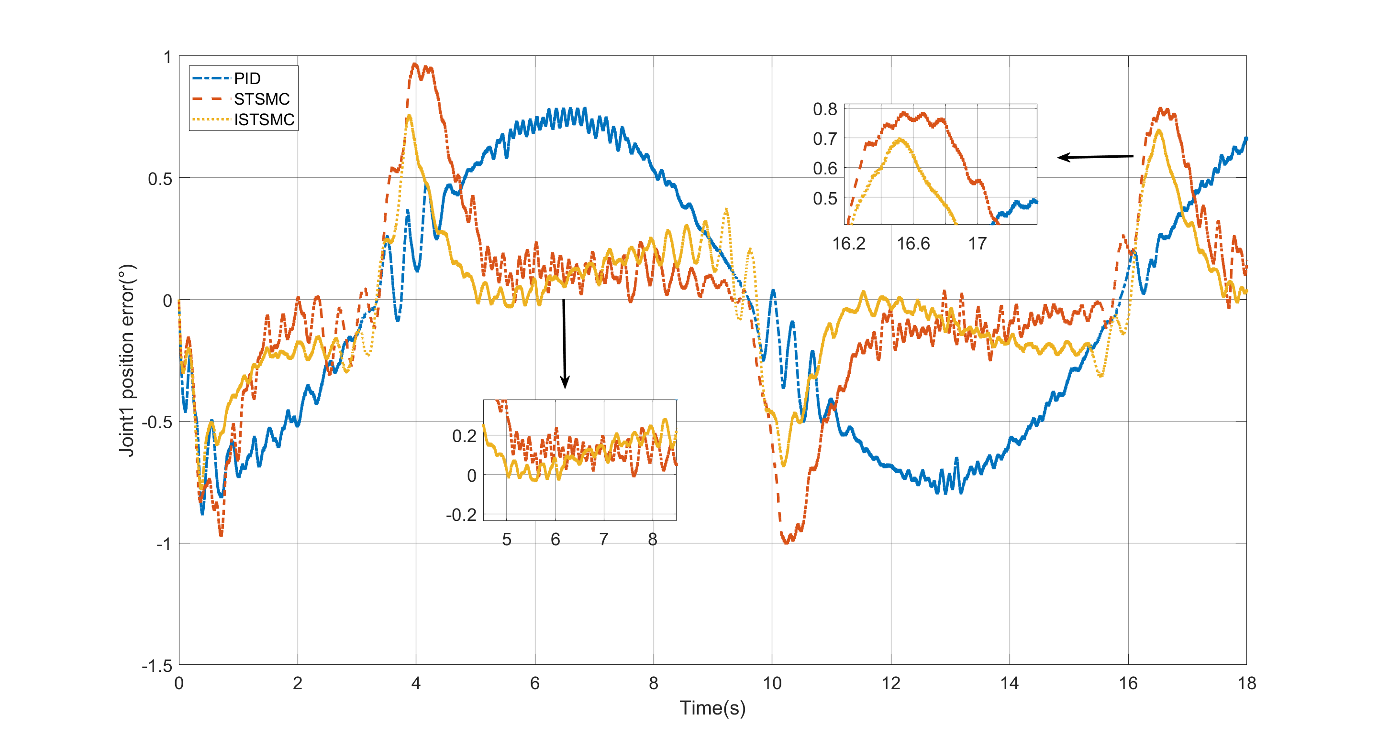 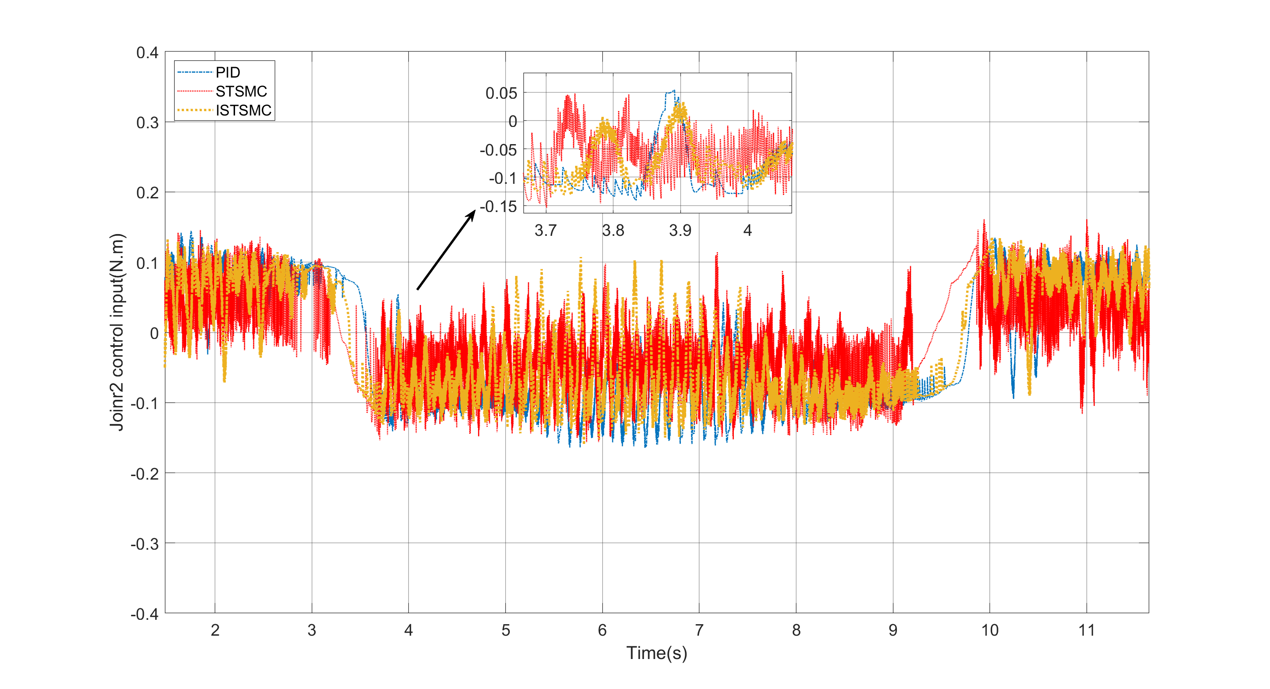

(b) (c)

Fig.3 Joint 1 under sine (a) Trajectory tracking diagram (b) Trajectory tracking error diagram(c) control input diagram

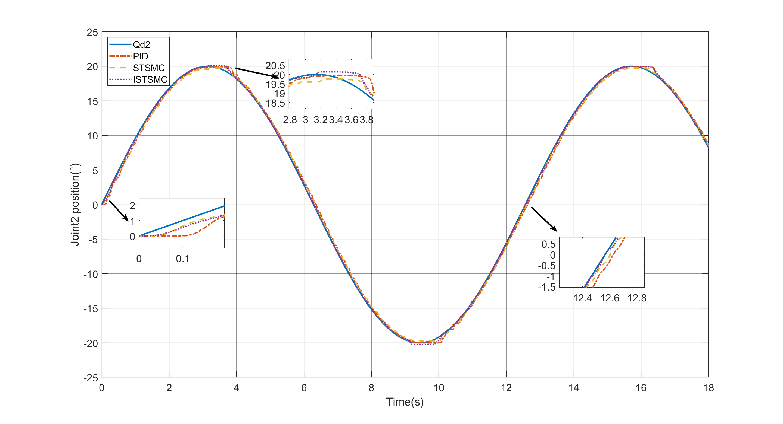

(a)

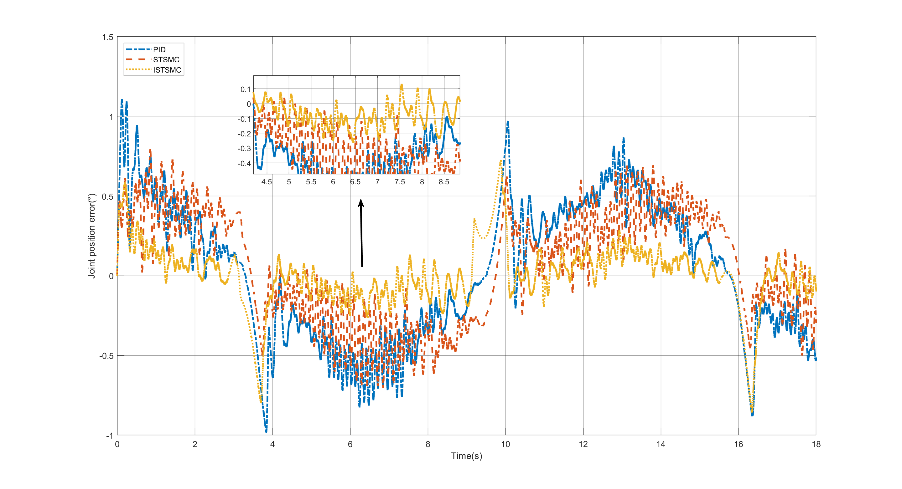 

(b) (c)

Fig.4 Joint 2 under sine (a) Trajectory tracking diagram (b) Trajectory tracking error diagram(c) control input diagram

5. Conclusion

In this paper, a ISTSMC is designed for the trajectory tracking control problem of flexible upper limb exoskeleton. The method ensures that the system is finite time convergence, and also reduces the system vibration caused by the switching function in the traditional STSMC integral term, and the experimental results verify that the controller designed in this paper has good tracking and vibration reduction effects. The effects of matching perturbations and coupling between joints on the system are neglected in the experiments, and observers are prepared to be added in the future to reduce the effects of perturbations and coupling.

References

1. Rana, J. S., Khan, S. S., Lloyd-Jones, D. M., & Sidney, S. (2021). Changes in mortality in top 10 causes of death from 2011 to 2018. *Journal of general internal medicine*, *36*(8), 2517-2518.

2. Shahbazi, M., Atashzar, S. F., Tavakoli, M., & Patel, R. V. (2016). Robotics-assisted mirror rehabilitation therapy: a therapist-in-the-loop assist-as-needed architecture. *IEEE/ASME Transactions on Mechatronics*, *21*(4), 1954-1965.

3. Mandeville, R. M., Brown, J. M., & Sheean, G. L. (2017). A neurophysiological approach to nerve transfer to restore upper limb function in cervical spinal cord injury. *Neurosurgical focus*, *43*(1), E6.

4. Prange, G. B., Jannink, M. J., Groothuis-Oudshoorn, C. G., Hermens, H. J., & IJzerman, M. J. (2009). Systematic review of the effect of robot-aided therapy on recovery of the hemiparetic arm after stroke.

5. Ates, S., Haarman, C. J., & Stienen, A. H. (2017). SCRIPT passive orthosis: design of interactive hand and wrist exoskeleton for rehabilitation at home after stroke. *Autonomous Robots*, *41*(3), 711-723.

6. Yu, W., & Rosen, J. (2010, December). A novel linear PID controller for an upper limb exoskeleton. In *49th IEEE Conference on Decision and Control (CDC)* (pp. 3548-3553). IEEE.

7. Kawase, T., Sakurada, T., Koike, Y., & Kansaku, K. (2017). A hybrid BMI-based exoskeleton for paresis: EMG control for assisting arm movements. *Journal of neural engineering*, *14*(1), 016015.

8. Kamavuako, E. N., Scheme, E. J., & Englehart, K. B. (2014). Combined surface and intramuscular EMG for improved real-time myoelectric control performance. *Biomedical Signal Processing and Control*, *10*, 102-107.

9. Siu, H. C., Arenas, A. M., Sun, T., & Stirling, L. A. (2018). Implementation of a surface electromyography-based upper extremity exoskeleton controller using learning from demonstration. *Sensors*, *18*(2), 467.

10. Rahman, M. H., K-Ouimet, T., Saad, M., Kenné, J. P., & Archambault, P. S. (2011, December). Tele-operation of a robotic exoskeleton for rehabilitation and passive arm movement assistance. In *2011 IEEE International Conference on Robotics and Biomimetics* (pp. 443-448). IEEE.

11. Fei, J., Wang, Z., Liang, X., Feng, Z., & Xue, Y. (2021). Fractional sliding mode control for micro gyroscope based on multilayer recurrent fuzzy neural network. *IEEE transactions on fuzzy systems*.

12. Razzaghian, A., Kardehi Moghaddam, R., & Pariz, N. (2021). Fractional-order nonsingular terminal sliding mode control via a disturbance observer for a class of nonlinear systems with mismatched disturbances. *Journal of Vibration and Control*, *27*(1-2), 140-151.

13. Razzaghian, A., Kardehi Moghaddam, R., & Pariz, N. (2021). Disturbance observer-based fractional-order nonlinear sliding mode control for a class of fractional-order systems with matched and mismatched disturbances. International Journal of Dynamics and Control, 9(2), 671-678.

14.Song, S., Zhang, B., Xia, J., & Zhang, Z. (2018). Adaptive backstepping hybrid fuzzy sliding mode control for uncertain fractional-order nonlinear systems based on finite-time scheme. IEEE Transactions on Systems, Man, and Cybernetics: Systems, 50(4), 1559-1569.

15. Rahmani, M., & Rahman, M. H. (2020). Adaptive neural network fast fractional sliding mode control of a 7-DOF exoskeleton robot. International Journal of Control, Automation and Systems, 18(1), 124-133.

16. Madani, T., Daachi, B., & Djouani, K. (2016). Modular-controller-design-based fast terminal sliding mode for articulated exoskeleton systems. IEEE Transactions on Control Systems Technology, 25(3), 1133-1140.

17. Yang, P., Ma, X., Wang, J., Zhang, G., Zhang, Y., & Chen, L. (2019). Disturbance observer-based terminal sliding mode control of a 5-DOF upper-limb exoskeleton robot. IEEE Access, 7, 62833-62839.

18. Hou, Q., Ding, S., Yu, X., & Mei, K. (2021). A super-twisting-like fractional controller for SPMSM drive system. IEEE Transactions on Industrial Electronics, 69(9), 9376-9384.

19. Ding, S., Park, J. H., & Chen, C. C. (2020). Second-order sliding mode controller design with output constraint. Automatica, 112, 108704.

20.Mei, K., & Ding, S. (2022). HOSM controller design with asymmetric output constraints. Science China Information Sciences, 65(8), 1-2.

21. Qian, C., & Li, J. (2006). Global output feedback stabilization of upper‐triangular nonlinear systems using a homogeneous domination approach. International Journal of Robust and Nonlinear Control: IFAC‐Affiliated Journal, 16(9), 441-463.

22. Rosier, L. (1992). Homogeneous Lyapunov function for homogeneous continuous vector field. Systems & Control Letters, 19(6), 467-473.